

Université Abdelmalek Essaâdi École Normale Supérieure - Tétouan Département informatique

Filière : M E-Learning et Systèmes Educatifs Intelligents (M ELSEI)
M121 Ingénierie pédagogique d’E-learning

A Blended Synchronous English Course: An Eclectic and ADDIE-Based Instructional Design for Moroccan Higher Education

Created by: | Supervised by:
KASSABI Taoufik | M. ERRADI

Content table
I. Introduction 4
II. Title and project details 5
III. Learning theory 5
IV. Learning objectives (Bloom’s taxonomy) 7
V. Educational design model (ADDIE) and its implementation 7
Analysis 8
Design 8
Development 9
Implementation 9
Evaluation 10
VI. UML Diagrams 11
• Class diagram 11
• Activity Diagram 11
• Sequence diagram (Synchronous activities) 12
• Sequence Diagram (Asynchronous Activities) 12
VII. Scenario of the course 13
Unit 1: Getting Started with English (2 Weeks) 13
Unit 2: Everyday Vocabulary in Context (2 Weeks) 13
Unit 3: Movies, Music, Books & Genres (2 Weeks) 13
Unit 4: Business English Foundations (2 Weeks) 13
Unit 5: Grammar in Practice (2 Weeks) 13
Unit 6: Real-Life Conversations (2 Weeks) 14
Unit 7: Listening & Speaking Skills (2 Weeks) 14
Unit 8: Final Project (2 Weeks) 14
VIII. Future Perspectives & Conclusion 14
IX. References 19

Table of figures
Figure 1: Class diagram of the course 9
Figure 2: Activity diagram of the course 9
Figure 3:Sequence diagram (Synchronous activities) 10
Figure 4: Sequence Diagram (Asynchronous Activities) 10
Figure 5: landing page of the App 13
Figure 6: Easy mode of the App 14
Figure 7: Hard mode of the App 15
Figure 8: App new design 16
Figure 9: app new design (continued) 16

Introduction

I've thankfully had the luxury of getting accepted into the master’s program of E-learning and Educational Systems here at ENS Martil, because the program miraculously mixes my interests in computer science, languages, and philosophy. And with the first year coming to an end, I decided to use new techniques and knowledge to create an efficient English language course—diverse, thoughtful, logical, and concise.
My English literature background from back when I was a student at the Abd al-Malek Sàadi University of Letters and Humanities, mixed with constant criticism of the dozens of English teachers I've encountered throughout the past decade, has led to only a few teachers genuinely fascinating me with their teaching strategies and methodologies, therefore, they are my project’s inspiration.
One of these teachers had a list of 150+ irregular verbs in their infinitive, past participle, perfect participle, and their Arabic translation, and we were tasked with memorizing the entire list. (Excel table will be included)
Each student was, at some point during class, suddenly and randomly chosen to pick five infinitive verbs out of a bowl of papers, and he would recite the remaining forms and the translation. The teacher would give feedback based on the answers.
His logic being: "An utterance's most important component is the action (verb) of the utterance itself. Adjectives and adverbs—and often even nouns—remain merely modifiers to the action."&
In simpler terms, the verb is the most important thing to understand in a sentence. He was focusing on the irregular verbs not only because memorizing all those forms would inherently increase their vocabulary too, but also because irregular verbs are the trickiest form of verbs. Unlike French, which has verbs of the 1er, 2ème, and 3ème group, English only has regular and irregular verbs (equivalent to the 1er and 3ème groups in French). Therefore, memorizing the tricky half would make learning the language ten times better and faster.
On the other hand, the second teacher encouraged sharing personal aspects about ourselves using English only in class. This helped the students get creative, more social—as if they were sharing parts and pieces of themselves and their personality. This gave a better atmosphere to class: it was personal, gamified, and super fun.
With these two crucial techniques that I’ve absorbed from my two previous favorite teachers, I present to you this detailed English course.

Title and project details
Title: "English Foundations: Building Real-World Communication Through Context and Practice"
Field: Languages and Communication / English for General Purposes
Structure: 8 units
Duration: 2 Weeks/Unit = 16 Weeks (¾ lessons/unit)
Public audience: University students struggling with English)
Learning format: Blended Synchronous Learning (Synchronous/Asynchronous)
Main objective: Optimise and improve English skills and be able to maintain conversations comfortably in professional settings.
Detailed objectives:
By the end of the course, learners will be able to:
- Engage in real-life conversations in English using proper vocabulary and grammar
- Identify and use formal/informal expressions based on context (academic, business, social)
- Improve vocabulary retention and usage through structured drills and contextual discovery
- Construct and present short oral and written presentations on familiar topics
- Improve expression and writing quality

Learning theory
Before we get to learning theory there are a handful of rules that the student must respect during live sessions (online or in class) to absorb the most amount of information out the sessions, and each rule follows a specific learning path.
- Focus; please pay attention in class since everything you hear will most likely be related to the session topic and will be helpful to you in some way or another in life
- English only; you must force yourself to speak English in class to relinquish the fear of speaking out and that will help your pronunciation immensely. (Verbal translation in Arabic is permissible under certain situations)
- Phones; allowed in class to look up spelling or definitions (no Arabic translations)
- Everyone should participate and attempt to share personal details to further get to know each other, and learners who are not participating will be chosen suddenly at random (any new information shared with everyone is good information)
- Group speaking activities; participants will be chosen at random.
- By the end of the course, learners should have already memorized at least 150 verbs in their infinitive, past and perfect participles, along with their Arabic translations. (sudden quizzes will be held, either as a consolidation or assignment)
The following classroom policies are not arbitrary rules, but carefully designed strategies grounded in pedagogical theory. Each one corresponds to a cognitive or behavioral pathway known to enhance second language acquisition in mixed-level learning environments.

Rule | Linked Learning Theory | Reason
Focus in class | Cognitivism | Encourages attention, encoding, memory
English only in class | Constructivism + Social Learning | Builds knowledge through use and interaction
Phone use (definitions only) | Cognitivism | Promotes deeper semantic processing
Forced participation / sharing | Social Learning + Constructivism | Peer modeling, engagement, relationship-based learning
Randomized group speaking | Behaviorism + Social Learning | Encourages alertness and structured practice
Verb memorization + quizzes | Behaviorism | Reinforcement through repetition and recall

This is what we call Eclectic Learning/Principled Eclecticism, it's perfect for modern language teaching methods as long as there’s a pedagogical reasoning behind each technique.

Learning objectives (Bloom’s taxonomy)
The table below shows how each activity in the course fits into Bloom’s Taxonomy. This helps make sure that learning starts with basic tasks like remembering words and grows into more advanced skills like giving feedback and creating full presentations. Each activity has a purpose and follows a clear learning path, which matches the mix of teaching methods used in this course. This way, students build up their language skills step by step — from memorizing, to understanding, to using English in real situations.
Level of Taxonomy | The Activity | Example in English Course | Why?
1. Remember | Students memorize 150 verbs (infinitive, past, participle, Arabic) through daily drills and sudden quizzes (Verb Bowl) | “Give the 3 forms of the verb to eat (eat, ate, eaten)” or “List 10 verbs from memory.” | Establishes essential vocabulary foundation; key for all language production.
2. Understand | Learners explain differences between formal and informal English, and describe movie genres using new words | “Explain the difference between do and make” or “Classify these words as formal/informal.” | Confirms learners grasp the meaning, not just memorize translations.
3. Apply | Students perform roleplays (e.g., at the doctor, job interview, restaurant) using target vocabulary and expressions | “Use new vocabulary in a roleplay (e.g. job interview, asking for directions).” | Moves learning from theory to real-life usage; builds fluency.
4. Analyze | Learners identify and correct grammar mistakes in group editing tasks; compare different genres of speech or writing | “Find and correct grammar mistakes in a peer’s paragraph” or “Compare two movie genres.” | Develops language awareness and deeper comprehension of structure and usage.
5. Evaluate | Students give feedback on peer recordings or presentations using a guided rubric | “Give feedback on a classmate’s oral presentation using a checklist.” | Builds critical thinking and reflective learning; prepares students for self-assessment.
6. Create | Final oral project: students design and deliver a personal presentation using learned vocabulary and expressions | “Prepare and deliver a personal 3-minute talk using learned vocabulary.” | Synthesizes all skills (grammar, vocab, speaking) in an authentic, creative task.

Educational design model (ADDIE) and its implementation

ADDIE is a well-known instructional design model used in education and training to plan, structure, and evaluate learning experiences. The acronym stands for Analysis, Design, Development, Implementation, and Evaluation, and each phase plays a specific role in building effective and goal-oriented instruction. ADDIE is widely used in e-learning, curriculum planning, and corporate training because of its logical flow and adaptability to different learning contexts. In this project, ADDIE serves as the foundation for structuring the English course, especially given the diverse needs of Moroccan learners, the blended synchronous format, and the focus on real-world language application. The following section outlines how each phase of ADDIE was applied in the design and delivery of the course.

Analysis
The analysis phase of the project considered multiple factors, such as:
- The mixed levels of English across various classes in Morocco. A large percentage of Moroccan students are proficient in French due to the French colonial period, since our parents and schools raised us to be good in French. However, many of these learners find English very difficult — even though they can sometimes use phonetic resemblance to understand a few words (e.g., introvert/extrovert vs. introverti/extraverti).
- The Moroccan students' fear of speaking out. This hesitation may stem from comparison with peers, lack of familiarity with English, fear of bad pronunciation, cognitive resistance toward English-related content, and many other reasons.
- The mix of multiple generations and linguistic tendencies in class. Studies have shown that younger generations — especially Gen Z (1997–2012) — have a much higher tendency to consume English content compared to earlier generations like Gen X and Gen Y. This is largely due to exposure to English-dominated digital platforms such as YouTube, TikTok, and Netflix, as well as the rise of economic sectors tied to English (IT, tourism, programming, outsourcing, etc.).

Design
The course is designed around 8 simple units, each built with a variety of activities that help learners feel both confident and comfortable throughout. Lessons are structured to gradually build vocabulary, improve fluency, and connect English use to the students’ own experiences. Activities range from verb memorization and vocabulary classification to speaking practice, roleplay, and project-based learning.
The lesson progression is aligned with Bloom’s Taxonomy — from memorizing verbs to giving feedback and finally creating original presentations — and the instructional methods are varied to reflect an eclectic approach, combining Behaviorism, Constructivism, Cognitivism, and Social Learning.

Development
The course contains a set of tools and materials designed to support both learners and instructors across each module.
Some examples include:
- A personalized verb list with infinitive, past, and participle forms (plus Arabic) to help students quickly build foundational vocabulary — inspired by real classroom needs and memory-based learning.
- Game-based activities like the “Verb Bowl”, which make memorization engaging and low-pressure.
- Vocabulary tasks linked to personal interests (e.g., business terms, favorite movie genres, and everyday vocabulary) to ensure relevance and motivation.
- Slide templates, vocabulary cards, and sentence starters that can be reused and adapted to reduce preparation time for instructors.
- Simple rubrics and checklists for peer feedback and project evaluation.
Each resource is connected to a specific learning theory to ensure the course remains student-centered and flexible enough to support a range of proficiency levels.

Implementation
This course follows a Blended Synchronous Learning (BSL) model — combining live (in-person or online) sessions with self-paced activities hosted on Moodle.
Synchronous sessions include:
- Group speaking tasks and roleplays
- Discussions based on student interests
- Real-time vocabulary games
- Randomized participation to encourage speaking
Asynchronous sessions allow students to:
- Watch short grammar/vocabulary videos
- Practice listening through curated clips
- Submit grammar corrections and short written reflections
- Prepare and rehearse for their oral project at their own pace
This approach gives learners flexibility while maintaining engagement, especially in large or mixed-level classrooms.

Evaluation
Evaluation is both formative and summative, designed to support learner progress and give regular feedback.
Formative assessments:
- Quick quizzes and memory tests (some surprise-based)
- Sentence correction tasks (individual or group)
- Peer interaction and in-class participation
- Feedback during roleplays and speaking exercises
Summative assessments:
- A final oral presentation where learners speak for 3 minutes on a topic of their choice using key vocabulary
- Evaluation of grammar accuracy, pronunciation, and vocabulary use
- Rubric-based self and peer assessments to promote metacognition and learner ownership
This blend of evaluation types ensures fair assessment while reinforcing learning, especially vocabulary retention and spoken fluency.

UML Diagrams

Class diagram
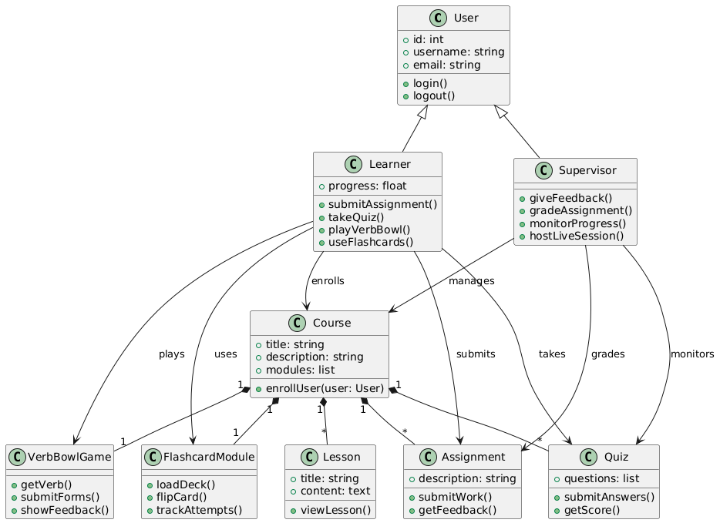
Figure 1: Class diagram of the course

Activity Diagram
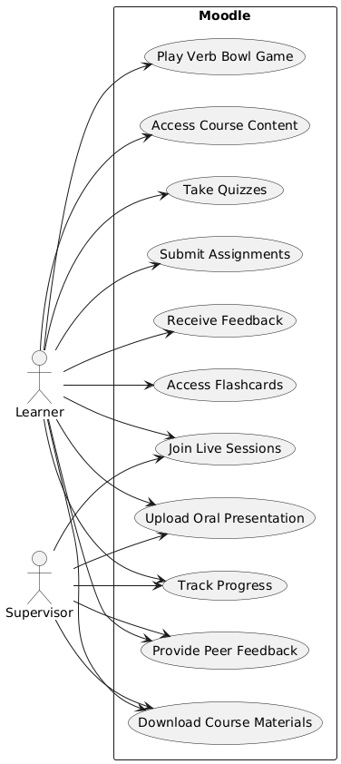
Figure 2: Activity diagram of the course

Sequence diagram (Synchronous activities)
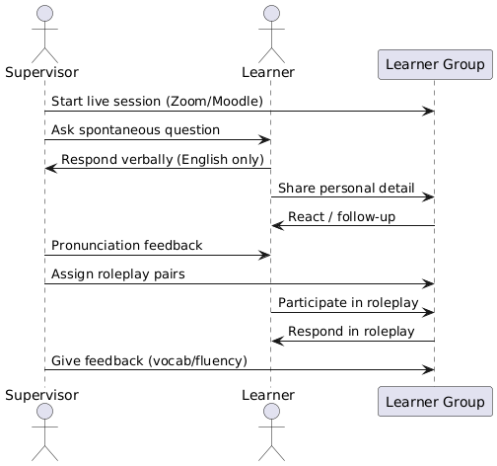
Figure 3:Sequence diagram (Synchronous activities)

Sequence Diagram (Asynchronous Activities)

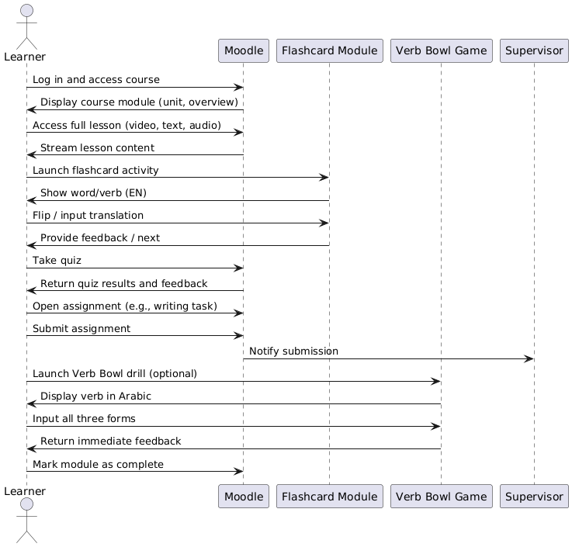
Figure 4: Sequence Diagram (Asynchronous Activities)

Scenario of the course

Unit 1: Getting Started with English (2 Weeks)

- Lesson 1: Course Introduction and Self-Introductions (Synchronous)
- Lesson 2: Daily English Expressions and Classroom Language (Synchronous)
- Lesson 3: Talking About Yourself and Your Background (Synchronous)
- Lesson 4: Vocabulary Recall Game (Verb Bowl) (Both)

Unit 2: Everyday Vocabulary in Context (2 Weeks)

- Lesson 5: Talking About Food, Cultures, Routines, and Hobbies (Synchronous)
- Lesson 6: Describing People and Places (Synchronous)
- Lesson 7: Vocabulary Grouping and Flashcard Building (Asynchronous)
- Lesson 8: Real-Life Vocabulary Games and Mini-Dialogues (Synchronous)

Unit 3: Movies, Music, Books & Genres (2 Weeks)

- Lesson 9: Discussing Favorite Media and Entertainment (Synchronous)
- Lesson 10: Classifying Genres and Describing Content (Synchronous)
- Lesson 11: Descriptive Vocabulary (Adjectives & Opinions) (Both)
- Lesson 12: Group Presentations on Favorite Media (Synchronous)

Unit 4: Business English Foundations (2 Weeks)

- Lesson 13: Identifying Formal and Informal Words (Both)
- Lesson 14: Expressions for Greetings, Meetings, and Emails (Synchronous)
- Lesson 15: Writing Basic Formal/Informal Messages (Asynchronous)
- Lesson 16: Vocabulary Roleplay: Interviews (Synchronous)

Unit 5: Grammar in Practice (2 Weeks)

- Lesson 17: Present, Past, and Future Tenses Overview (Synchronous)
- Lesson 18: Common Grammar Errors and Correction (Both)
- Lesson 19: Verb Conjugation Recall and Drill (Both)
- Lesson 20: Grammar Games and Group Corrections (Synchronous)

Unit 6: Real-Life Conversations (2 Weeks)

- Lesson 21: Roleplay: Store, Transport, Doctor, Street (Synchronous)
- Lesson 22: Asking and Giving Directions (Synchronous)
- Lesson 23: Building Mini-Dialogues (Synchronous)
- Lesson 24: Listening Practice from Real Clips (Asynchronous)

Unit 7: Listening & Speaking Skills (2 Weeks)

- Lesson 25: Listening for Key Info (Asynchronous)
- Lesson 26: Summarizing and Retelling (Both)
- Lesson 27: Peer Interviews and Self-Recordings (Synchronous)
- Lesson 28: Vocabulary Quiz + Mock Oral Test (Both)

Unit 8: Final Project (2 Weeks)

- Lesson 29: Planning the Oral Project (Synchronous) ...
- Lesson 30: Writing the Structure and Rehearsing (Both) ...
- Lesson 31: Final Presentations (Synchronous) ...
- Lesson 32: Individual Feedback and Course Review (Synchronous) ...

Future Perspectives & Conclusion

Looking ahead, the development of this English language course is far from complete. The next major step involves fully integrating the course into an online learning management system such as Moodle or Blackboard. These platforms will allow for a comprehensive and accessible learning experience that accommodates various learning styles and needs. The digital version of the course will include a structured curriculum with accompanying digital books, video lectures, interactive quizzes, assignments, and live video sessions to foster real-time interaction between students and instructors.
These features will ensure that the course is not only informative but also engaging, flexible, and inclusive.
An exciting avenue for expansion is the gamification of learning tasks through tools like H5P, which will allow the incorporation of interactive content directly into the online modules. One of the standout activities from the course, the “Verb Bowl”, is is now being adapted into an H5P activity. This gamified exercise, originally built with HTML, CSS, and JavaScript, is already fully functioning and has proven to be a dynamic and effective way to help students memorize irregular verbs.

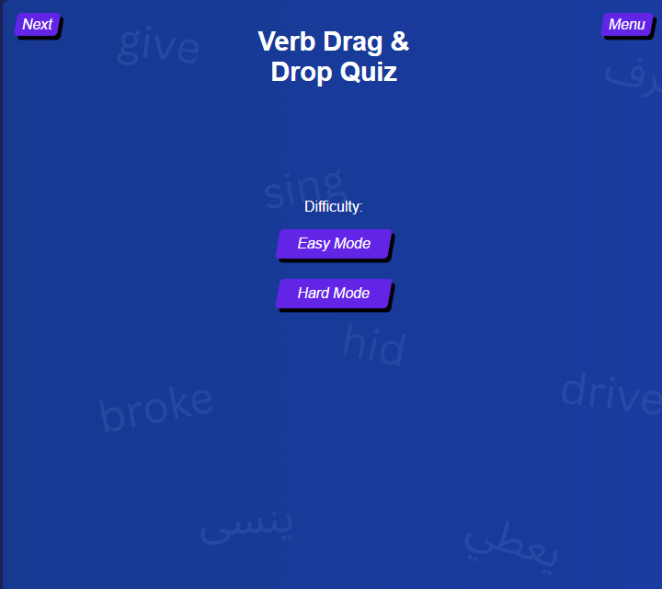
Figure 5: landing page of the App

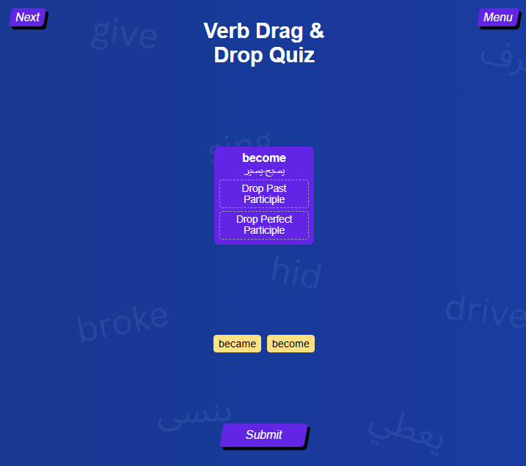
Figure 6: Easy mode of the App

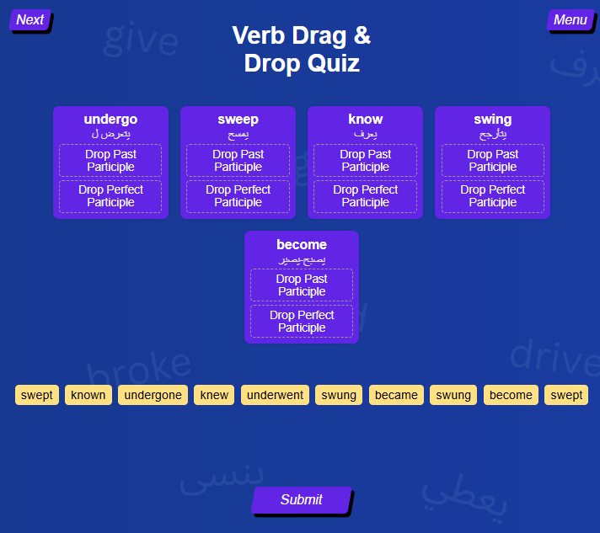
Figure 7: Hard mode of the App

The current plan is to wrap the JavaScript functionality within an H5P content type, ensuring it can be seamlessly embedded into learning management systems while retaining interactivity and accessibility.
This will be enhanced by a remastered web design that offers a smooth, modern learning experience as seen bellow.

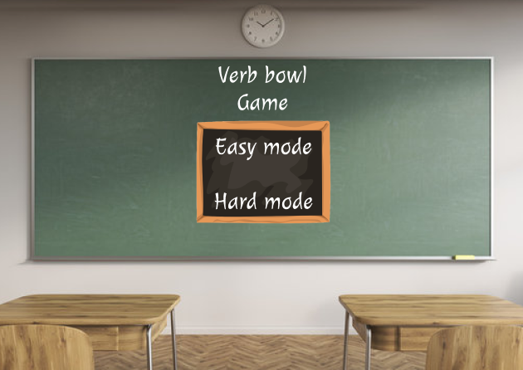
Figure 8: App new design

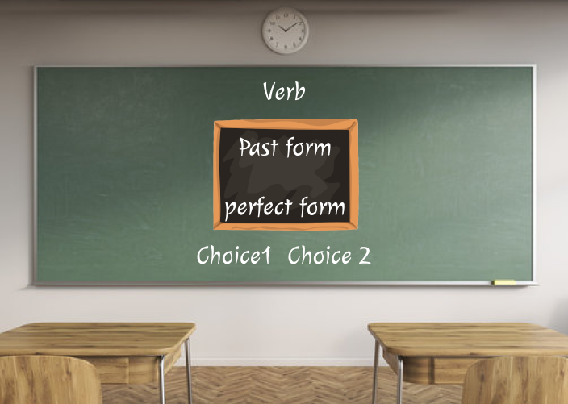
Figure 9: app new design (continued)

The goal is not only to digitize traditional methods but to rethink how English language learning can be delivered—making it more intuitive, culturally aware, and responsive to real-world communication needs.

Final version of the project will soon be published on my Github so feel free to check it out or maybe even use it for your own English learning/teaching projects.

References

The Perceived Value of English in Moroccan Society Across Generational Lines - Johanna Broten
https://h5p.org/developers
https://www.aihr.com/blog/addie-model/
Using an Eclectic Approach to Design Curriculum Instruction in an Online Environment - William Chakabwata
https://tips.uark.edu/using-blooms-taxonomy/

